Emergency Mock Drill (Silent hours)

Type: | Unplanned fire mock drill
Scenario: | Fire in Loop Reactor Plant 2nd & 3rd floor.
Location: | Loop Reactor
Date: | 4th Dec. 2016 (3rd Dec. night shift)
Emergency start at: | 01.59 a.m.
All Clear declared at: | 02.19 a.m.

Description of Mock Drill:

Time | Activity
01.59 a.m. | - After hearing gas detector activated sound in DFA control room, DFA shift in-charge immediately contacted to Loop reactor operator and instructed him to go and assess the situation.  - Operator while trying to go to Loop reactor 2nd floor, he sensed heat so he immediately operated the fire alarm-MCP & called co-operator for help.  - Fire caught to the Hydrogen leaked through the gland of Hydrogen line control valve block valve of Loop old reactor.  - Operator tried to use CO2 extinguisher & second operator tried to spread water using hose reel from 2nd floor.
02.01 a.m. | - After hearing the fire alarm activated sound, shift in-charge rushed to the incident – Loop reactor 2nd floor.  - Then he started to guide the operators for firefighting.  - After getting information from shift in-charge about the incident, DCS operator informed to security gate-1& Fatty Alcohol control room about incident.  - DCS operator closed Hydrogen line XV & control valve. And he informed through paging to Loop reactor operator to close block valve of Hydrogen line.  - Shift in-charge did paging about the fire incident in Loop reactor.
 | - Shift in-charge communicated the emergency to night manager, DFA plant head. EHS head.
02.05 a.m. | - Same time shift in-charge observed Nickel catalyst bags kept at 3rd floor, started melting & caught fire.  - Shift in-charge informed to DCS operator about the spreading of fire at 3rd floor and asked for help from other department & to declare the stage II emergency.
02.06 a.m.  02.08 a.m. | - Declared stage II emergency  - Meanwhile Duty ASI along with firemen reached at site and started fire  fighting from DFA side and also DFA field operators started fire fighting  from ground floor.  - While doing fire fighting one DFA plant operator slipped from staircase &  fell. His leg was twisted. One operator informed this to shift in-charge.  - Shift in-charge informed DCS control about the injury & called help from  Gate-1 for ambulance.
02.15 a.m. | - Ambulance reached at site & with the help of DFA plant operators,  injured person shifted to OHC.  - Male nurse gave him first aid & informed to security to shift the injured  person outside hospital for further treatment.
 | - Meanwhile fire fighting was continue.
- After informing to shift in-charge, security person permitted to shift
injured person outside.
02.19 a.m. | - Fire got extinguished, after assessing the situation conducted head count then shift in charge informed to control room to declare all clear.  All clear declared through PA system
02.22 a.m. | - Plant HOD informed the situation to Unit head

Positive Points:

- Overall response time was good (from other for emergency reporting & emergency handling was very good.
- Sequence to emergency handling was in line.
- Support from other departments (Fatty Alcohol, Security), Fire fighting team was as per expectation.
- Fire alarm/MCP operated & found satisfactory.
- First aid given at OHC was excellent.

Advantage of the activity:
- Checked performance of emergency light all over in plant by electrical persons at stair cases in plants & other areas. Found satisfactory.

Observers:
- Prabhat Das
- Sunil Katekari, AGM – EHS & Fire
- Satish Jadhav, Sr. Manager – Electrical
- Dhairyasheel Shinde, Sr. Manager – EHS
- Pradeep Soshte, Asst. Manager – EHS
Scope of improvement:
Sr. | Observation | Recommendations | Responsibilities
1 | Emergency not communicated to unit head during activity. | External communication needs to improved | HR/EHS
2 | Head count | Need improvement | HR/EHS
3 | Electrician not reached to Fire hydrant pump house immediately after emergency declaration | Need training | HR/EHS
4 | Ambulance reached at site very late | Provision required to be made for emergency communication to Ambulance driver | HR/EHS
5 | First aiders from other departments available in shift not reported to incident site | Training | HR/EHS

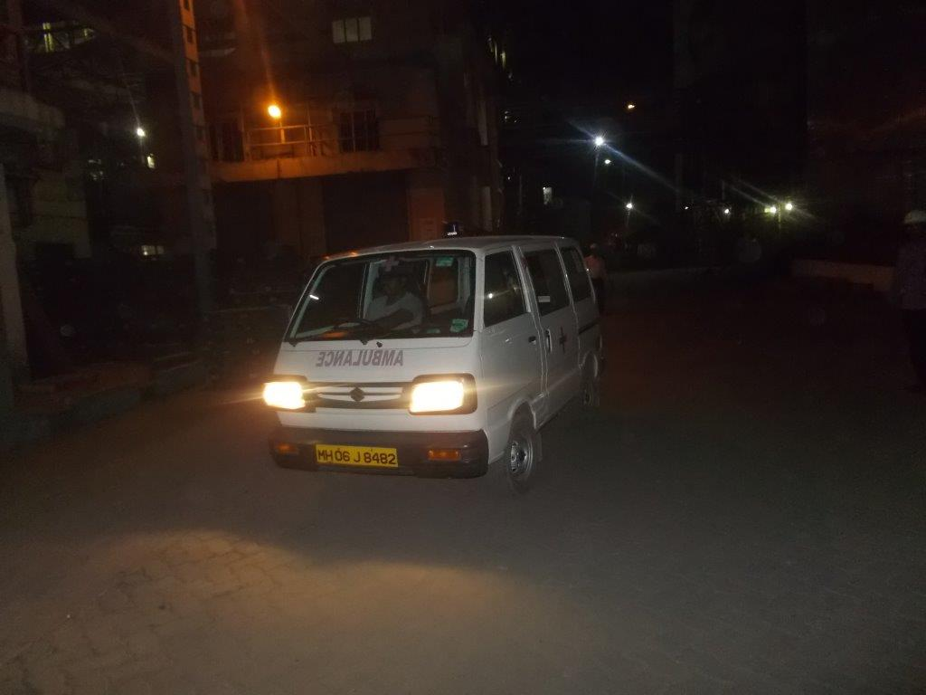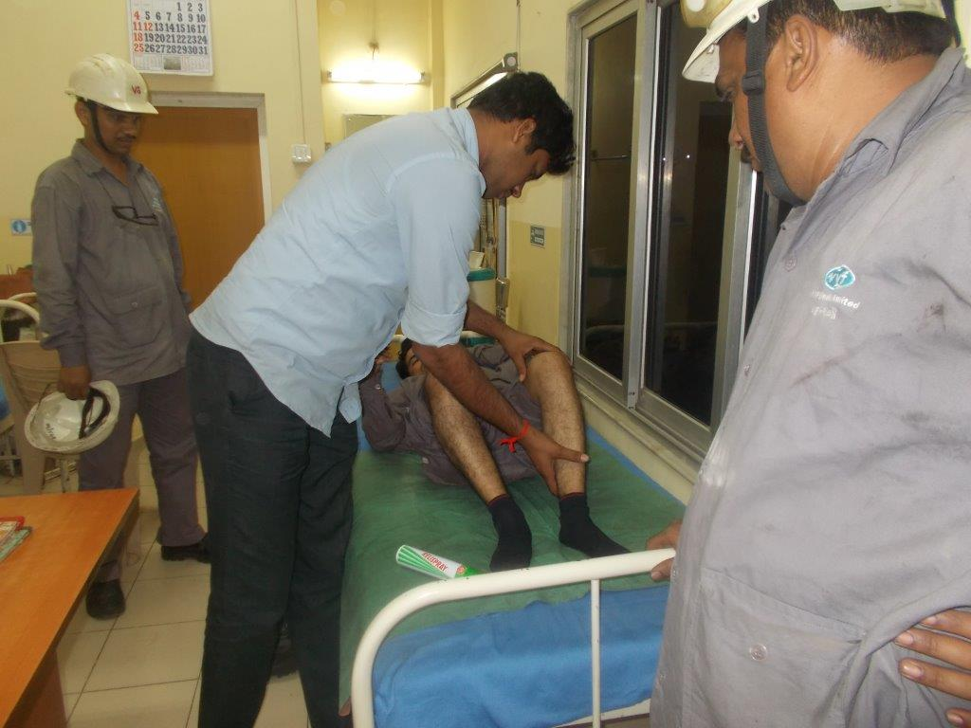

SUNIL S KATEKARI
AGM – EHS

